|  |
| --- |
| cyborg7 |
| Arcade Game Final |
| **Documentation** |
| Version 1  All work Copyright © 2012 by XX Games.  All rights reserved. |
| **By: Gurinder Verma** |
|  |



|  |
| --- |
| April 17th 2015 |

Table of Contents

Version History 3

Game Overview 4

Game Play Mechanics 4

Controls 4

Saving and Loading 4

Interface Sketch 4

Menu and Screen Descriptions 5

Game World 5

Game Progression 6

Characters 6

Enemies 6

Scripts 6

Scoring 6

Cheat Codes 6

Design Notes 7

Future Features 7

Sound Index 7

Art / Multimedia Index 7

References 8

# Version History

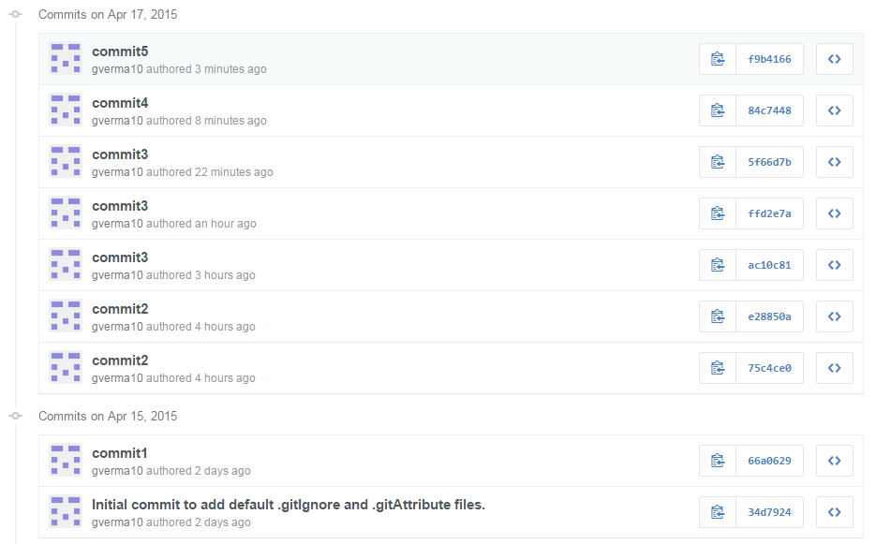

# Game Overview

*This is an arcade game in which the player has to save the paper plane from dangers. The player will get five lives to go, and has to hit the maximum score. The player should prick the bubble with the paper plane and avoid the coming winds. Each time the player collides with wind will lose one life and for each bubble the player will get ten points.*

# Game Play Mechanics

*The game is about the player controlling the paper plane and save it from the front coming winds and prick as many bubbles as possible.*

# Controls

*The only control that could be used in this game is the mouse. The user can move the paper plane with the help of the mouse up and down.*

# Saving and Loading

*No such feature as saving and loading has been added so far, but could be implemented in the upcoming versions.*

# Interface Sketch

*The game interface will give the player instruction at the beginning and then the user can start the game and play.*

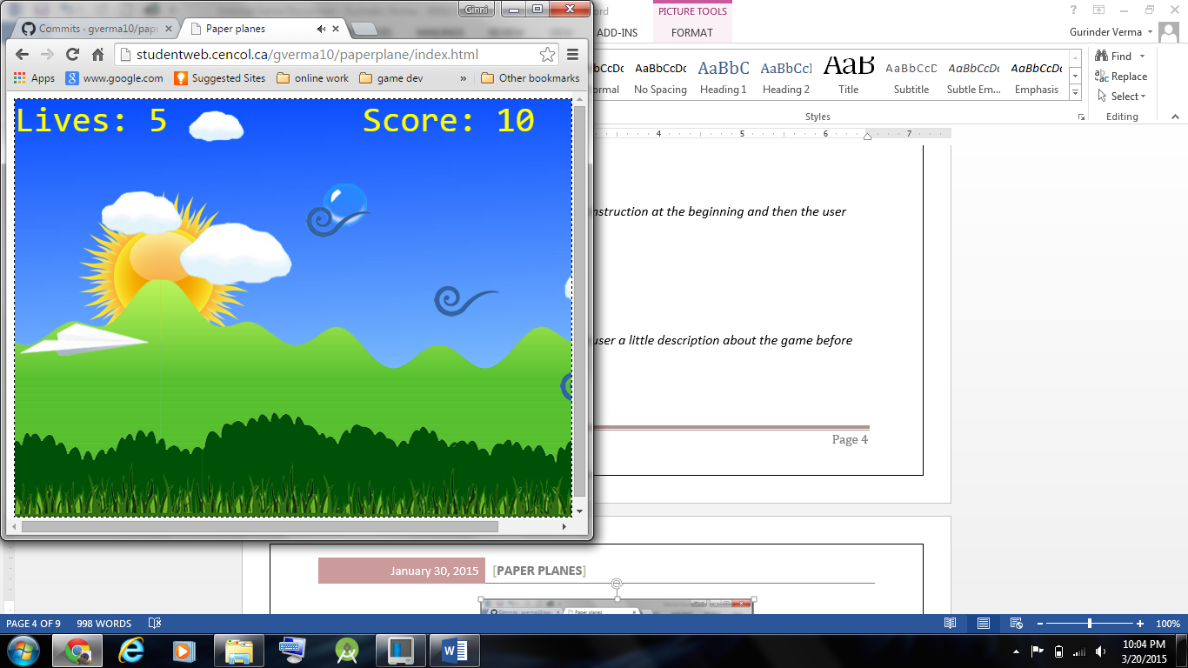

# Menu and Screen Descriptions

*The game have a menu which gives the user a little description about the game before starting it. And the end screen will show the user*his score and the high score.

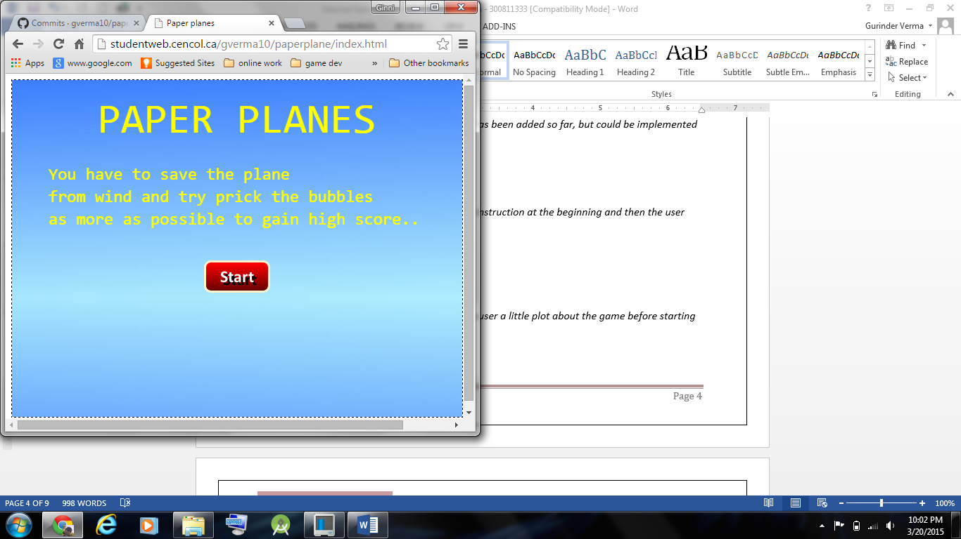

# Game World

*The game is on imaginary environment in which a paper plane is flying and the player has to save it from the wind.*

# Game Progression

*The game progresses as the user keeps on saving the paper plane and will end if the player gets out of lives.*

# Characters

*There is no physical character in the game but as its arcade game, the player is to control the paper plane.*

# Enemies

*The player has to tackle the front coming wind. If he collides with it the player will lose a life for that.*

# Scripts

*Creation of this game was done in JavaScript.*

# Scoring

*The player can score infinite, as the player prick bubble each time he will be awarded ten points for that.*

# Cheat Codes

*No cheat codes are applicable for this game so far as the difficulty level is not much. But could be considered in the forthcoming versions.*

# Design Notes

*The designing of the game is kept simple to make it more user friendly. And the images used are from the various external sources.*

# Future Features

*In future the new features could be introduces like 3D characters, virtual weapons, sound effects, graphical rendering, etc.*

# Sound Index

*The game has only three sounds*

* *Bubble.mp3 – for the bubble prick*
* *Planecrash.mp3 – for the paper plane hit with wind*
* *Wind.mp3 – blowing wind throughout the game*

# Art / Multimedia Index

*The development of game has many images*

* blue-bubble-shiny.png



* bushes.png



* cloud_1.png



* cloud_2.png



* cloud_3.png



* cloud_4.png



* cloud_5.png



* dat-to-night.png



* day08_paperplane.png



* grass.png



* mountains.png



* playagain.png



* start.png



* sunmoon.png



* swirl.png



# References

*The images used in this are taken from various sources*

* *Google images*
* *Hdwallpaers*
* *Superbwallpaers*
* *Wallpapersguy*

*The buttons used in this are taken from website*

* *dabuttonfactory*